**Nama:** Clive Clay Irawan

**NIM:** 2702373412

1. **Traversal Binary Tree**

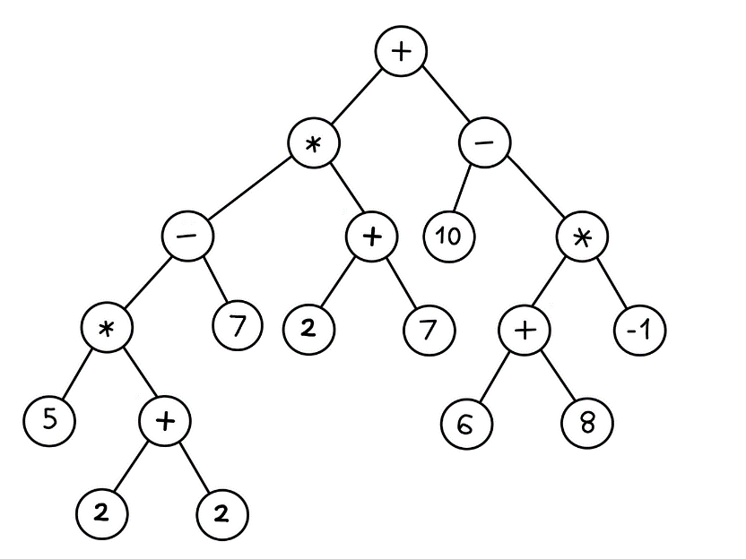



From expression tree above, create:

1. Infix notation: ((((5*(2+2))-7) *(2+7)) + (10-((6+8) *-1)))
2. Prefix notation: +*-*5+227+27-10*+68-1
3. Postfix notation: 522+*7-27+*1068+-1*-+
4. **Create expression tree**



From:



1. Prefix: /*3+214

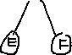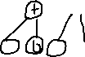

1. Postfix: AB+CD-/EF*-

